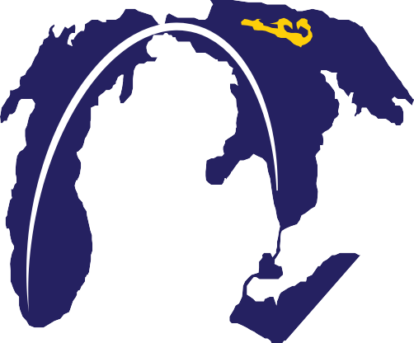

**SUPER MAC RACE - 2017**

**July 15-20, 2017**

**Bayview Yacht Club, Chicago Yacht Club, and Port Huron Yacht Club**

**Sailing Instructions**

**1. Conditions**

The Race is conducted in conjunction with the 2017 Chicago Yacht Club Race to Mackinac, the Notice and Conditions of Race and Sailing Instructions for which shall apply, except as modified or supplemented by these Sailing Instructions. To participate, each yacht shall be entered in and comply with the rules and requirements of the Chicago Yacht Club Race to Mackinac.

**2. Management**

From the start until the finish of the Chicago Yacht Club Race to Mackinac, the

Race will be sailed under the management of the Chicago Yacht Club Mackinac Race Committee. Thereafter, it will be sailed under the management of the Bayview Yacht Club Mackinac Race Authority through the finish. The Super Mac Race finish shall be administered by the Port Huron Yacht Club Finish Line Race Committee.

**3. Divisions and Classes**

Section breaks for the Chicago Yacht Club Race to Mackinac shall be posted at registration. Yachts will start in their assigned sections as directed by those Sailing Instructions. For the Super Mac Race, divisions/classes will be established by combining or altering the Chicago Yacht Club Race to Mackinac sections. Announcement of the Super Mac Race divisions/classes will be posted before the start on the Official Notice Board of the Chicago Yacht Club Race to Mackinac at Chicago Yacht Club and available on the online Official Notice Board on the Super Mac Race website: <https://yachtscoring.com/emenu.cfm?eID=4222>.

**4. Notices to Competitors**

Prior to the Race, notices to competitors shall be posted on the Official Notice Board of the Chicago Yacht Club Race to Mackinac. After the start, notices to competitors will be posted on the Official Notice Board of the Super Mac Race website with copy posted to a courtesy notice board located in the Port Huron Yacht Club.

**5. Courses and Marks**

**5.1** The initial course will be as described in the Sailing Instructions for the Chicago Yacht Club Race to Mackinac. Amendments to those Sailing Instructions shall be binding for all competitors in the Super Mac Race.

**5.2** Upon crossing the finishing line for the Chicago Yacht Club Race to Mackinac, proceed to the finish line for the Super Mac Race leaving Round Island, Bois Blanc Island, and Thunder Bay Island to starboard.

**6. Finish Line Procedures**

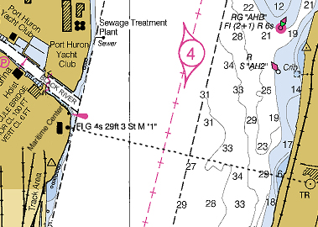**6.1** The finish line shall be between an orange flag at the Maritime Center (also known as Winkworth Transit Co.) just south of the Black River in Port Huron and a radio tower at approximately

42° 58.221N, 082° 24.525W on the Canadian shore of the St. Clair River as shown in the chart to the right.

**6.2** Competitors are required to contact the Finish Line Race Committee when passing the green channel marker “7” in the Lake Huron entrance channel for the St. Clair River by calling VHF channel 71 or by telephone at 734-644-2058 if unable to reach the committee by radio.

**6.3** When approaching the finish line each yacht shall display a signboard with reflective sail numbers along the lifelines on the starboard side aft of the beam, whether day or night. At night every effort should be made to illuminate the signboard to assist with identification of the finishing yacht. Failure to display the signboard shall automatically result in a penalty of 15 minutes additional corrected time.

**6.4** Finish Line Race Committee will attempt to acknowledge each finish by a sound signal. Immediately after finishing and clearing the finish line, each yacht should confirm its finish on VHF channel 71. Each yacht should record its own finish time on the form provided with these Sailing Instructions.

**6.5** A representative of a finished yacht shall sign in at the Finish Line Race Committee located in a trailer in the parking lot on the west side of the Maritime Center within four hours of finishing. This sign-in is the yacht’s representation that the yacht has raced in full compliance with the rules of the Race. Yachts that are entered in the 2017 Bell’s Beer Bayview Mackinac Race shall not turn in their GPS tracking unit in Port Huron and will use those units for that race. Yachts that are not entered in the 2017 Bell’s Beer Bayview Mackinac Race shall turn in their GPS tracking unit into the Finish Line Race Committee.

**7. Time Limit**

Yachts which do not finish by 1700 EDT Thursday, July 20, 2017, shall take their own time and submit their finish cards at the Port Huron Yacht Club. Yachts that fail to finish by 0800 EDT, Friday, July 21, 2017, will be scored Did Not Finish without a hearing. This changes rules 35, A4 and A5.

**8. Withdrawal**

Yachts that withdraw from the Super Mac Race after crossing the Chicago Yacht Club Race to Mackinac finish line must notify the Super Mac Finish Line Race Committee by telephone at 734-644-2058.

**9. Protests**

**9.1** Yachts entered in both the Super Mac Race and the Chicago Yacht Club Race to Mackinac that are involved in a protest shall have only one protest hearing and, when appropriate, the protest committee’s decision shall apply to both races.

**9.2** If the incident being protested occurs before both yachts clear the finish line of the Chicago Yacht Club Race to Mackinac, the hearing will be held by the Chicago Yacht Club Race to Mackinac protest committee in Chicago at a time to be set after both races are finished. Yachts intending to protest that are continuing in the Super Mac Race shall so inform the Chicago Yacht Club Mackinac Race Committee at Mackinac Island by VHF radio channel 78 or telephone 906-847-3303 within two hours of finishing at Mackinac Island. Protests shall be delivered to the Super Mac Finishing Line Race Committee at the Port Huron Yacht Club within four hours of finishing.

**9.3** If the incident being protested occurs after both yachts have cleared the finish line of the Chicago Yacht Club Race to Mackinac, the protest will be heard by the Super Mac Race Protest Committee at Port Huron Yacht Club.

**9.4** Protests shall be submitted on the standard US Sailing form, copies of which will be available at the Port Huron Yacht Club. Protests shall be filed within four hours of finishing the Super Mac Race. Notice of all protests shall be posted on the Official Notice Board on the Super Mac Race website with a courtesy copy posted on a notice board at Port Huron Yacht Club. The posted notices will constitute the notice required under RRS 63.2.

**9.5** Protests shall be heard at Port Huron Yacht Club beginning at 1100 EDT Thursday, July 20, 2017.

**9.6** RRS 44.1 and 44.2 shall not apply.

**9.7** Penalties assessed for protests may include disqualification or additional time shall be added to the yacht’s elapsed time for the Super Mac Race. This changes RRS 44.3.

**10. Inspection**

Boats may be selected at random for inspection after finishing. Upon finishing, boats selected for inspection will be notified by the Race Committee on VHF channel 71. Boats that refuse to follow such instructions, hinder the inspection process or are found not in compliance with the Mackinac Equipment Requirements are subject to protest by the Race Committee only.

**11. Scoring**

Each boat shall be ranked by her corrected time in Class and Division. The lowest corrected time wins. Corrected times shall be calculated using the Chicago ORR Offshore – All Purpose course configuration for monohulls and GLMRA for multihulls.

**12. Awards**

Flags will be awarded to winners at Port Huron Yacht Club at 1900 EDT Thursday, July 20, 2017. Flags will be given for 1st, 2nd, and 3rd in class for the ORR Division and 1st and 2nd for the Multihull Division. Trophies will be awarded at the Bayview Yacht Club Mackinac Awards Dinner on Saturday, October 21, 2017, at the Roostertail in Detroit, MI .

**Bayview Yacht Club Port Huron Yacht Club   
Chicago Yacht Club**

**Super Mac Race**

**July 15-20, 2017**

**Finish Card**

**Sail Number _____________________________________________________**

**Boat Name ______________________________________________________**

**Owner’s Name ___________________________________________________**

**Finish Time (EDT) _________________________________________________**

**Boat Ahead ______________________________________________________**

**Boat Astern ______________________________________________________**

**Owner’s Signature ________________________________________________**